Table 1. Chemical characteristics of the soil in the three sampling points of of Conilon coffee cultivated in association with banana trees in summer (S) and winter (W) of 2012.
 | pH | P | K | S | Fe | Zn | Cu | Mn | B | Na | Ca | Mg |  | H+Al | MO
 |  | ......................................mg/dm³................................ |  |  |  |  |  |  |  |  | Dag/Kg
T1 | 6,7 | 6,0 | 54,6 | 5,0 | 95,6 | 2,7 | 0,9 | 49,6 | 0,45 | 29,6 | 2,8 | 0,8 |  | 1,2 | 2,2
T2 | 6,5 | 6,3 | 23,6 | 4,6 | 82 | 2,2 | 0,4 | 40,3 | 0,3 | 11,3 | 2,2 | 0,7 |  | 1,5 | 2,2
T3 | 6,3 | 5,0 | 32,0 | 4,6 | 83,3 | 2,0 | 0,6 | 39,3 | 0,51 | 15,6 | 2,1 | 0,6 |  | 1,5 | 1,7
T1: coffee row at 5, 25 meters, T2: coffee row at 1, 75 meters, T3: coffee row at from the banana trees.

Table 2. Length of the internodes of the plagiotropic and orthotropic branches, leaf area, average yield (2012, 2013 and 2014) of Conilon coffee cultivated in association with banana trees in summer (S) and winter (W) of 2012.
 | RPCF(V) | PRPP(V) | RPJ(V) | RO(V) | AF(V) | RPJ(I) | RO(I) | AF(I)
T1 | 5,3a | 4,5a | 5,4a | 4,3a | 70,8a | 4,6a | 3,1a | 72,5a
T2 | 5,1a | 4,3a | 5,3a | 4,3a | 72,3a | 4,6a | 3,3a | 74,1a
CV% | 12,93 | 12,84 | 10,87 | 16,19 | 21,97 | 9,75 | 20,23 | 22,09
Means followed by the same letter in the same column are not significantly different from one another according to Tukey’s test (P<0.05). T1: coffee row at 5, 25 meters, T2: coffee row at 1, 75 meters, T3: coffee row at from the banana trees. Plagiotropic branches with fruits (PBWF), tip of the productive plagiotropic branches (TPPB), young plagiotropic branches (YPB), orthotropic branches (OB) AND leaf area (LA).

Table 3. Average amount of chlorophyll in the leaves of Conilon coffee cultivated in association with banana trees in summer (S) and winter (W) of 2012.
 | Clorofila a |  | Clorofila b |  | Clorofila Total
 | Verão | Inverno | Verão | Inverno | Verão | Inverno
T1 | 39,2a | 42,6a | 14,3b | 42,7a | 53,5b | 85,3a
T2 | 40,3a | 41,9a | 20,7a | 42,3a | 61,0a | 84,3a
CV% | 4,16 | 4,65 | 41,10 | 26,04 | 14,93 | 14,03
Means followed by the same letter in the same column are not significantly different from one another according to Tukey’s test (P<0.05). T1: coffee row at 5, 25 meters, T2: coffee row at 1, 75 meters, T3: coffee row at from the banana trees.

Table 4. Mean concentrations of N, P, K, Ca, Mg and S (g.Kg⁻¹) and Fe, Zn, Cu, Mn and B (mg Kg⁻¹) in leaves of coffee associated with rubber trees in summer 2012.
Concentração nutricional foliar
 | N | P | K | Ca | Mg | S | Fe | Zn | Cu | Mn | B
T1 | 26,0a | 1,4a | 9,0b | 17,3a | 4,1a | 1,3a | 57,4a | 8,6a | 7,8a | 43,2a | 81,2a
T2 | 25,0a | 1,3b | 14,8a | 14,8b | 2,7b | 1,1b | 51,0a | 8,4a | 5,8a | 35,6a | 62,8b
CV% | 4,20 | 2,63 | 11,11 | 6,10 | 6,31 | 7,04 | 15,59 | 10,52 | 21,81 | 13,43 | 8,21
Means followed by the same letter in the same column are not significantly different from one another according to Tukey’s test (P<0.05). T1: coffee row at 5, 25 meters, T2: coffee row at 1, 75 meters, T3: coffee row at from the banana trees.

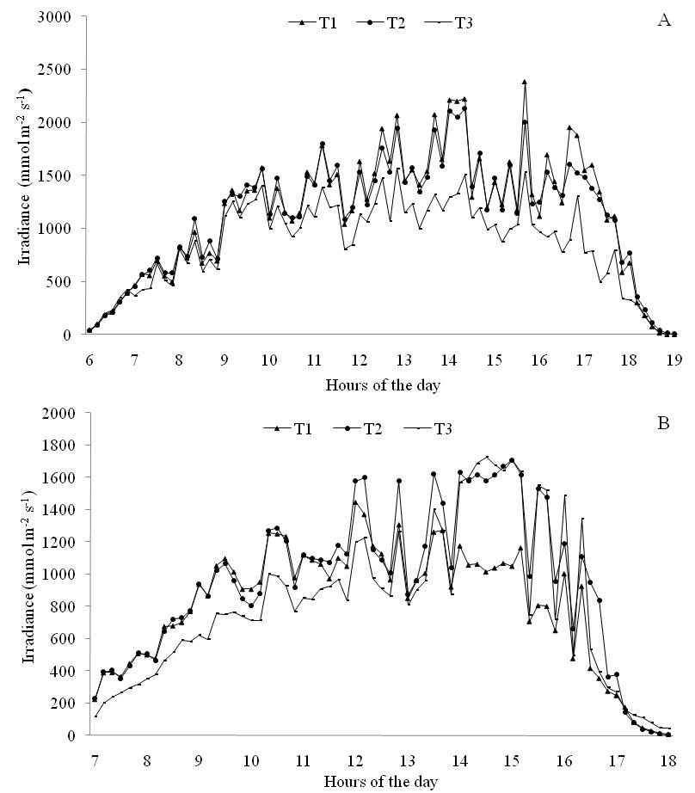
Figure 1. Daily irradiance values in a coffee plantation associated with bananas trees in summer (A) and winter (B). T1: coffee row at 5, 25 meters, T2: coffee row at 1, 75 meters, T3: coffee row at from the banana trees.

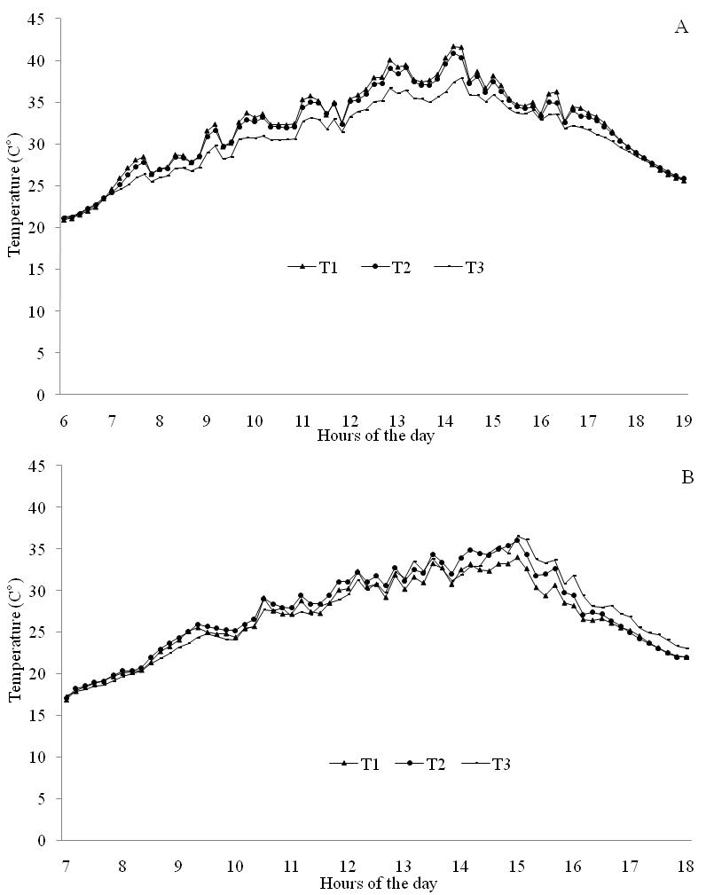
Figure 2. Daily temperature values in a coffee plantation associated with bananas trees in summer (A) and winter (B). T1: coffee row at 5, 25 meters, T2: coffee row at 1, 75 meters, T3: coffee row at from the banana trees.

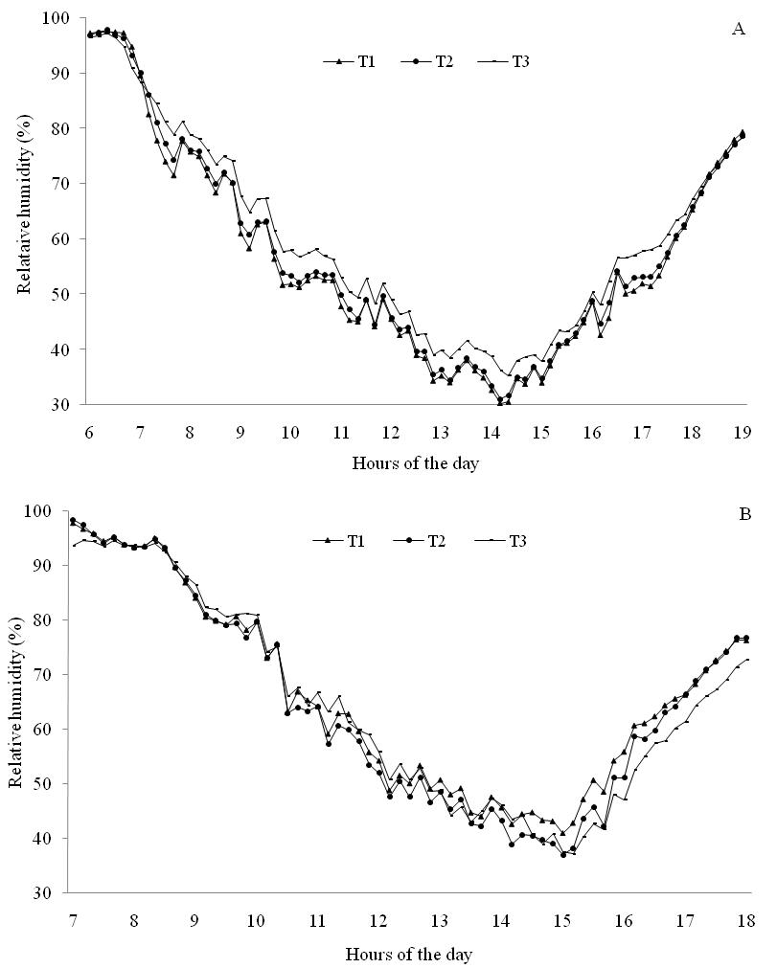
Figure 3. Daily relative humidity values in a coffee plantation associated with bananas trees in summer (A) and winter (B). T1: coffee row at 5, 25 meters, T2: coffee row at 1, 75 meters, T3: coffee row at from the banana trees.

