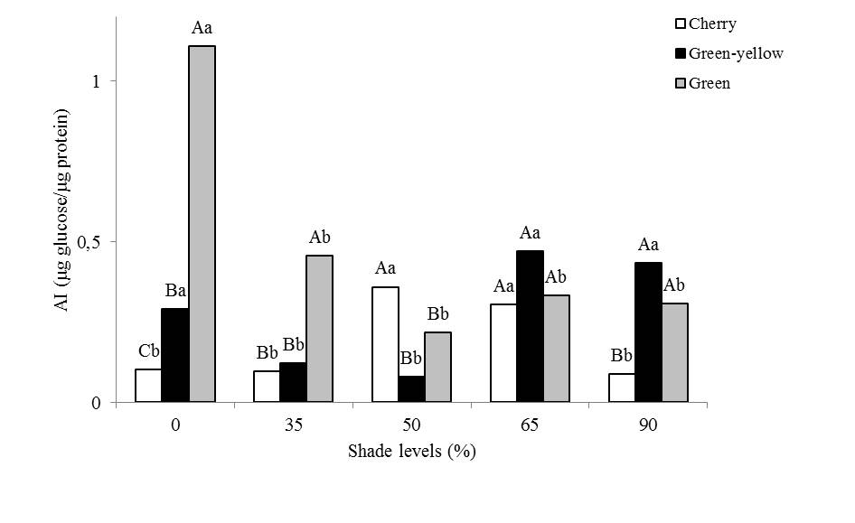
Figure 1 – Graphical representation for acid invertase activity in fruits of coffee in function of shade levels and stages of maturation. Capital letters compare means among the fruits development stages within each shade levels, and lower case letters compare means of each development stages among shade levels (Scott Knott – p ≤ 5 %).

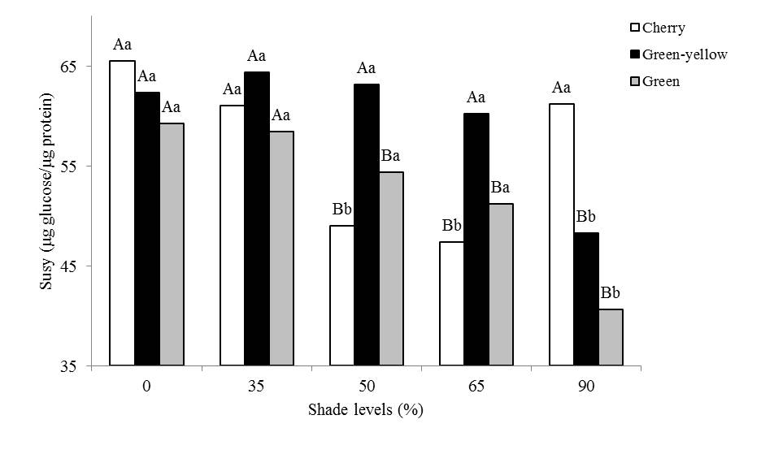
Figure 2 – Graphical representation for Susy activity in fruits of coffee in function of shade levels and stages of maturation. Capital letters compare means among the fruits development stages within each shade levels, and lower case letters compare means of each development stages among shade levels (Scott Knott – p ≤ 5 %).

Table 1 – Mean values ​​of the enzymatic activity of sucrose phosphate synthase (SPS) for different stages of fruits ripening of coffee trees.
Shade levels | SPS (µg glucose/µg protein)
Cherry | 56,36 a
Green-yellow | 56,40 a
Green | 51,30 b
Mean | 54,68
⁽¹⁾Means followed by the same letter do not differ by the Scott Knott test at 5%.

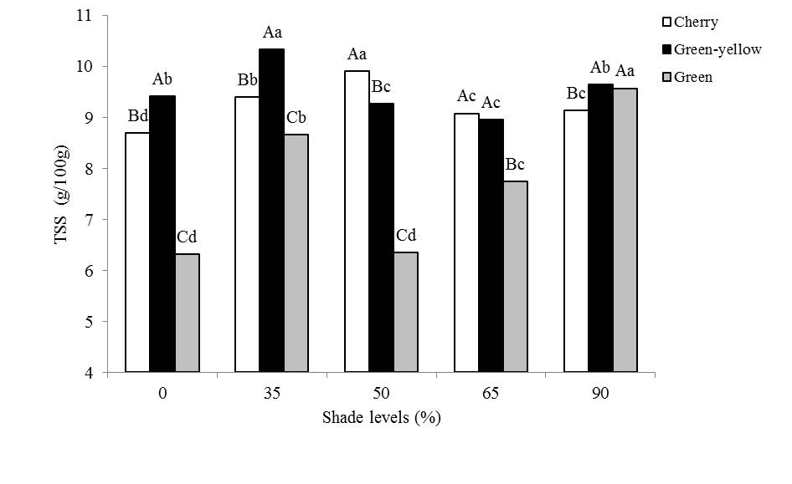
Figure 3 – Graphical representation for total soluble sugars in fruits of coffee in function of shade levels and stages of maturation. Capital letters compare means among the fruits development stages within each shade levels, and lower case letters compare means of each development stages among shade levels (Scott Knott – p ≤ 5 %).

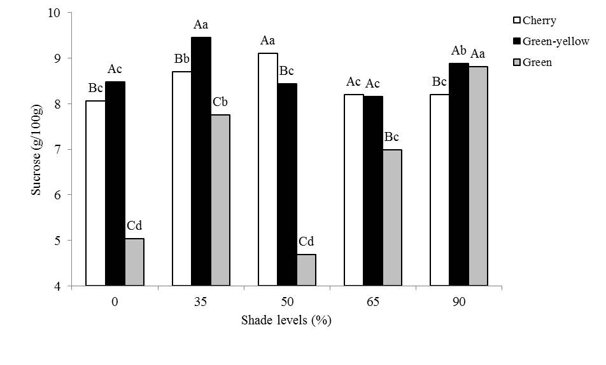
Figure 4 – Graphical representation for sucrose in fruits of coffee in function of shade levels and stages of maturation. Capital letters compare means among the fruits development stages within each shade levels, and lower case letters compare means of each development stages among shade levels (Scott Knott – p ≤ 5 %).

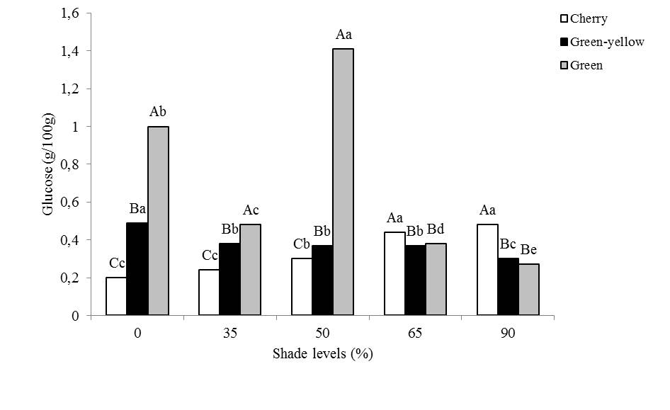
Figure 5 – Graphical representation for glucose in fruits of coffee in function of shade levels and stages of maturation. Capital letters compare means among the fruits development stages within each shade levels, and lower case letters compare means of each development stages among shade levels (Scott Knott – p ≤ 5 %).

