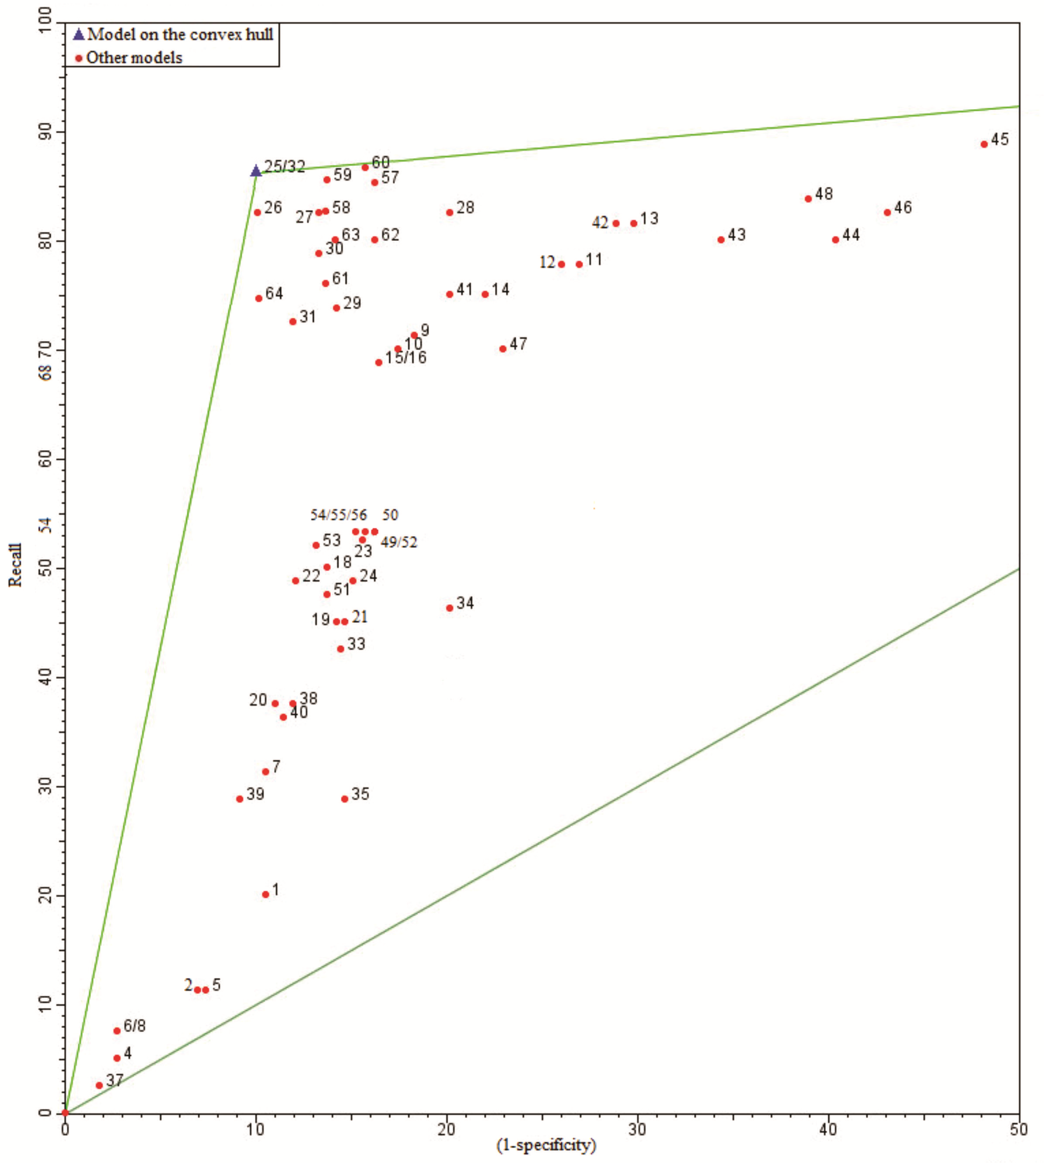
FIGURE 2 – ROC graph with the performance points for the models developed and the model selected on the convex hull for low fruit load years.

