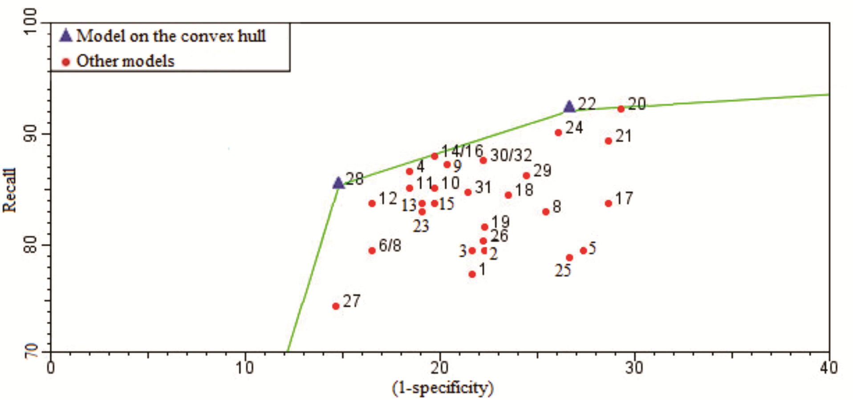
FIGURE 1 – ROC graph with the performance points for the models developed and selected on the convex hull for high fruit load years.

