**CERTIFICATE**

To the Editorial Board

This is to certify that the paper “**THE PROFILE OF SMALL COFFEE PRODUCERS IN THE SOUTH OF MINAS GERAIS, BRAZIL”,** by Wanêssa Tavares Campos Corsini, Fábio dos Santos Corsini, Luciana de Paula Naves, Marina Ariente Angelocci, Leandro Carlos Paiva and Fernando Ferrari Putti, was corrected by the undersigned, who is a native speaker of English, and is grammatically and stylistically to standard.

Maringá PR Brazil, 7th August 2017.

Yours truly,

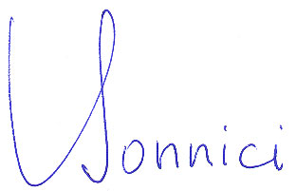

_______________________________

Dr. Thomas Bonnici

I.D. card 563 250

Department of English, State University of Maringá, Maringá PR Brazil.