Table 1. Fertilization performed on coffee plants in the agricultural years 2008/2009 and 2009/2010.
Fertilization¹ |  |  | Limestone | Thermophosphate | Poultry litter | Castor bean pie
 |  | ---------- g hole⁻¹ ---------- |  |  | ------- g of DM hole⁻¹-------
Plantiing |  |  | 50,00 | 300,00 | 750,00 | ---
Covering | (Dez/Jan 2008) |  | --- | --- | 325,00² | ---
Covering | 1º Year (2008/2009) | --- |  | --- | 653,25³ | ---
Covering | 2º Year (2009/2010) | --- |  | --- | --- | 304,85
Covering | 2º Year (2009/2010) | --- |  | --- | 1044,00 | ---
Covering | 2º Year (2009/2010) | --- |  | --- | --- | 383,24
Covering | 2º Year (2009/2010) | --- |  | --- | --- | 304,70
¹ It was calculated considering the recommendation 300 kg ha⁻¹ year⁻¹ of N (GUIMARÃES et al., 1999);
² It was applied in two installments; ³ It was applied in three installments.

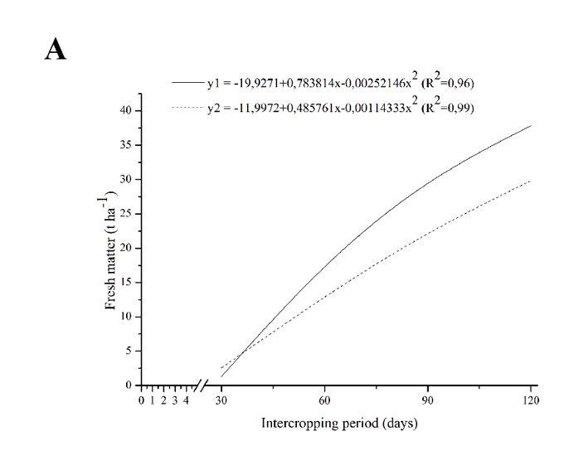 | 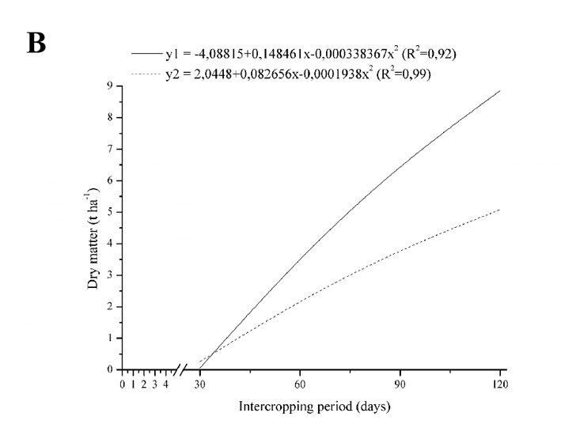
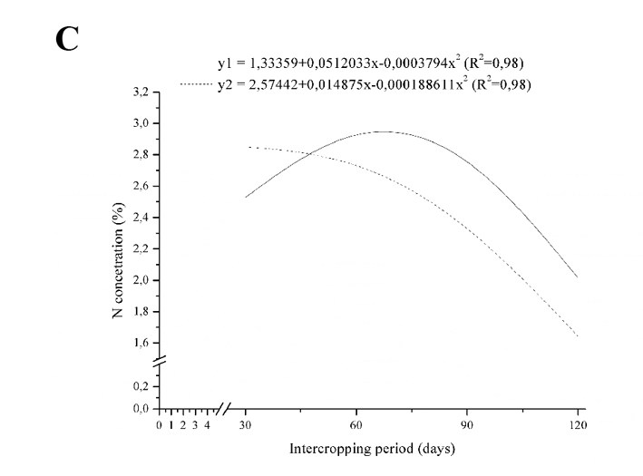 | 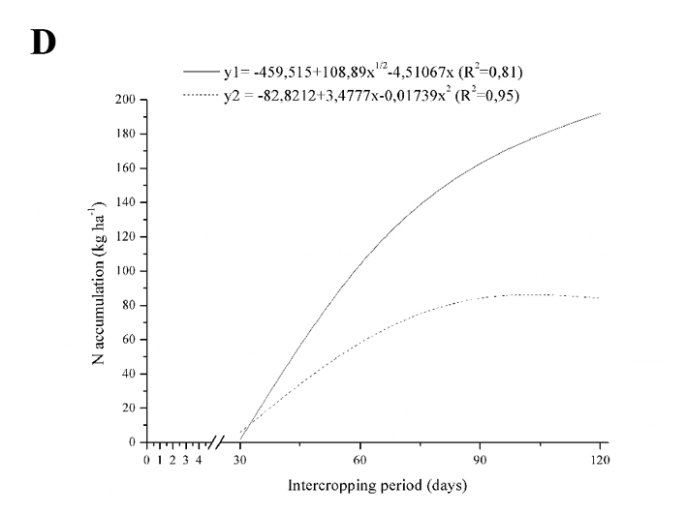
Figure 1. Fresh and dry matter accumulation (t ha⁻¹, A e B respectively), N concentration (%, C) and accumulation (kg ha⁻¹, D) in the green manure C. ensiformis (y1) and D. lablab (y2) intercropped with coffees in 2009/2010.

Table 2. Height increase in 2010 (cm) on each intercropping period and in the organic fertilizers with 50% and 100% of the dose; and diameter increase in 2010 (Diam 2010 cm) diameter accumulated in 2009 and 2010 (Diam acum, cm) of intercropping coffee plants with C. ensiformis and D. lablab.
SPECIES | HEIGHT 2010 |  |  |  |  |  |  | Diam  2010¹ | Diam  acum¹
SPECIES | Intercopping period¹ |  |  |  |  | Fertilization² |  | Diam  2010¹ | Diam  acum¹
SPECIES | 30 DAS | 60 DAS | 90 DAS | 120 DAS |  | 50% | 100% | Diam  2010¹ | Diam  acum¹
C. ensiformis | 30,60 A | 27,25 A | 28,17 A | 31,67 A |  | 28,70a B | 30,14aA | 11,05 b | 60,06 b
D. lablab | 23,97 B | 29,88 A | 32,14 A | 36,39 A |  | 32,18a A | 29,01aA | 15,66 a | 65,57a
¹ Means followed by the same letter, in the same column do not differ by Tukey test (p≥0,05).
² Means followed by the same letter, lowercase and uppercase on the line in the column, do not differ by Tukey test (p≥0,05).

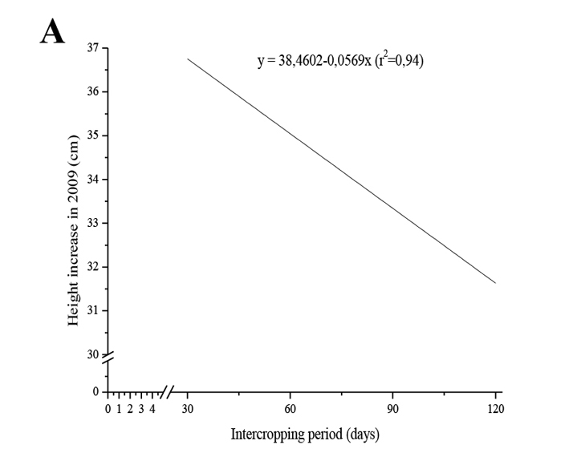 | 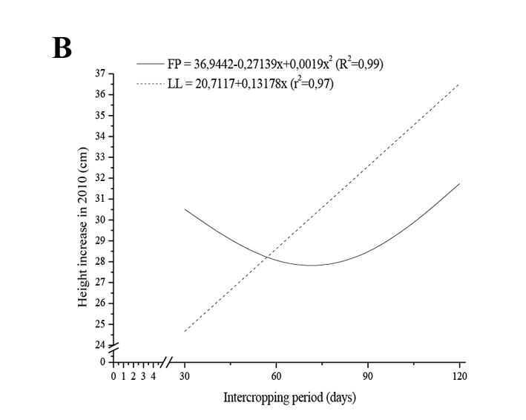
Figure 2. Height increase in 2009 (A) e 2010 (B) of the coffee plants, due to the kind of green manure intercropped (C. ensiformis and D. lablab), on each intercropping period.

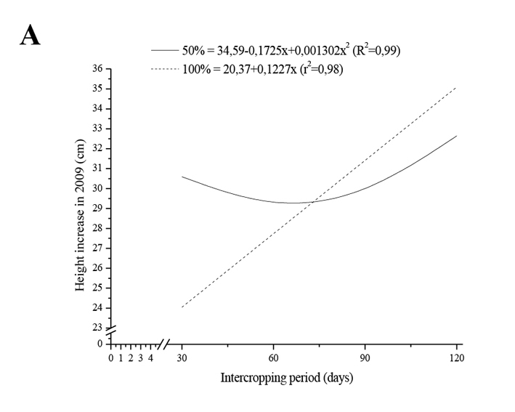 | 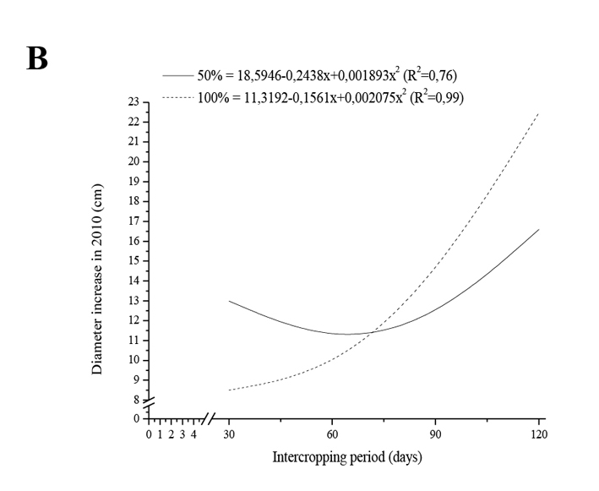
Figure 3. Height increase and diameter increase crown in 2010 of coffee plants with 50% and 100% organic fertilization.

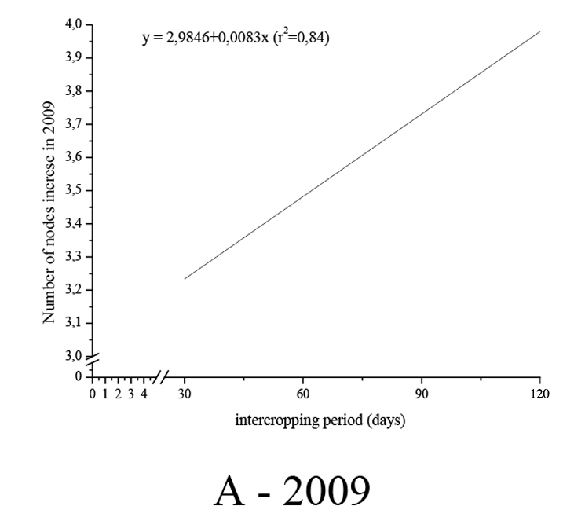 | 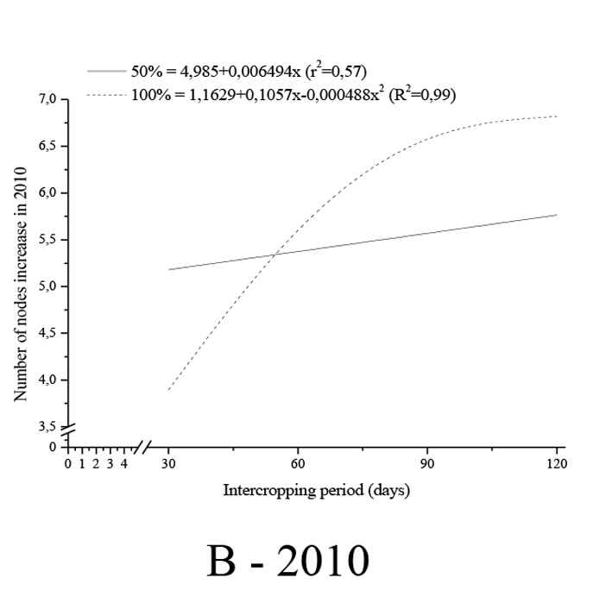 | 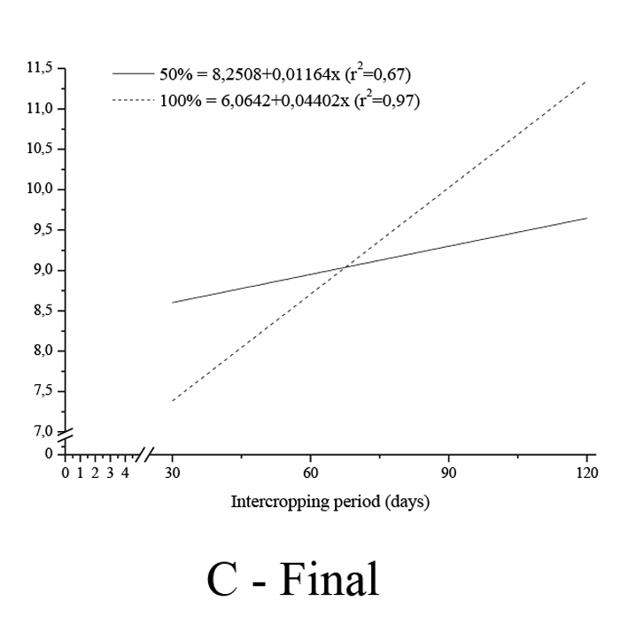
Figure 4. Number of nodes increase in 2009 (A), in 2010 (B) and final number of nodes (C) of the coffee plants on each intercropping period with the legumes and with 50% e 100% of the recommended fertilization.

Table 3. Nitrogen leaf concentrations (N, %) in the coffee plants at 30 and 150 days after the seeding of the legumes (DASL) C. ensiformis e D. lablab, in the agricultural years 2008/2009.
SPECIES | MANAGEMENT | CN 30DASL | CN 150DASL
SPECIES | MANAGEMENT | (%) | (%)
C. ensiformis | 30 | 2,58 B | 3,05 B
C. ensiformis | 60 | 2,57 B | 3,19 B
C. ensiformis | 90 | 2,65 B | 3,54 A
C. ensiformis | 120 | 2,74 B | 3,61 A
D. lablab | 30 | 2,53 B | 3,14 B
D. lablab | 60 | 2,76 A | 3,25 B
D. lablab | 90 | 2,56 B | 3,56 A
D. lablab | 120 | 2,85 A | 3,44 B
Testemunha |  | 2,49 B | 3,16 B
CV (%) |  | 6,03 | 6,06
Means followed by the same letter in the column do not differ from the control by the Dunnett test (p≥0,05).

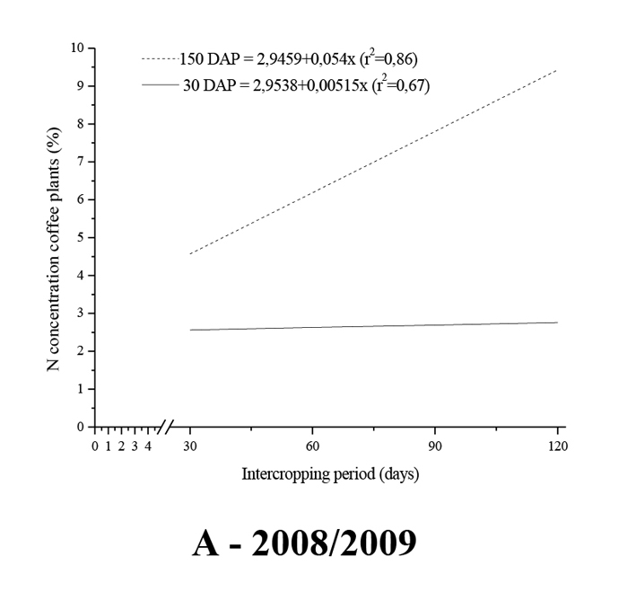 |  | 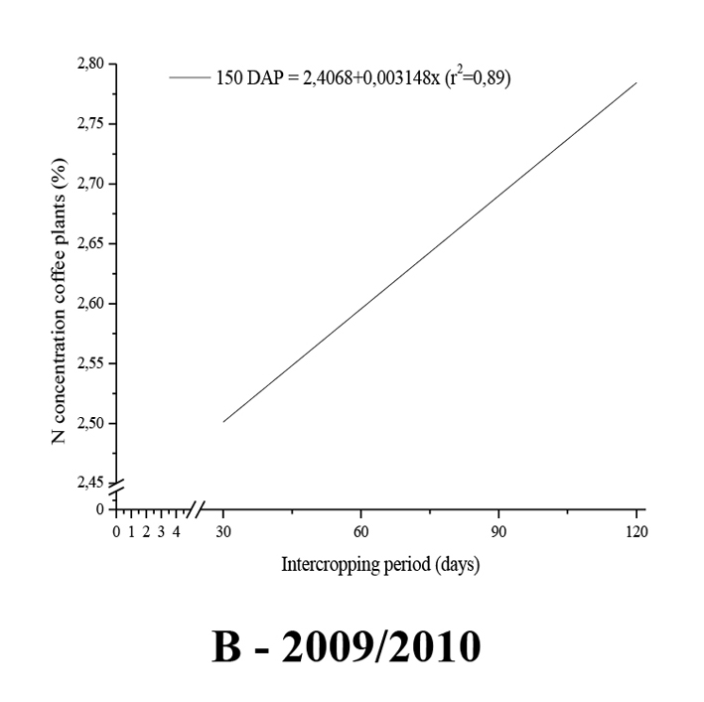
Figure 5. Nitrogen leaf concentrations in the coffee plants at 30 and 150 days after the seeding of the green manure on each intercropping period with the legumes (30, 60, 90 and 120 DASL) in the agricultural years 2008/2009 and 2009/2010.

Table 4. Nitrogen leaf concentrations (N, %) inn the coffee plants at 30 and 150 days after the seeding of the green manure C. ensiformis and D. lablab (DASL), and with 50% and 100% of the recommended fertilization, in the agricultural year 2009/2010.
Variable |  |  | N (%)
 |  |  | 30DASL | 150DASL
Species | C. ensiformis |  | 2,79 a | 2,58 b
Species | D. lablab |  | 2,70 b | 2,70 a
Fertilization | 50% |  | 2,68 b | 2,61 b
Fertilization | 100% |  | 2,81 a | 2,68 a
Means followed by the same letter in the column do not differ from the control by the Tukey test (p≥0,05).

Table 5. Cherry coffee (CC, t ha⁻¹), grain benefited (GB, t ha⁻¹), grain yield (Rend, %), productivity (Pr, sc ha⁻¹) and average biennial productivity (PrMBienal, sc ha⁻¹) in the coffee fertilized with 100% fertilization, intercropping with C. ensiformis (FP) and D. lablab (LL) under 4 cutting periods (30, 60, 90 and 120 DASL), in the agricultural years 2009/10 and 2010/11.
ESP | MAN | ADUB | CC2010 | GB2010 | Rend2010 | Pr2010 | CC2011 |  | GB2011 |  | Rend2011 |  | Pr2011 |  | PrMBienal
ESP | MAN | % | t ha⁻¹ | t ha⁻¹ | % | sc ha⁻¹ | t ha⁻¹ |  | t ha⁻¹ |  | % |  | sc ha⁻¹ |  | sc ha⁻¹
Test |  | 100 | 3,72 A | 1,40 A | 37,78 A | 23,41 A |  | 0,89 A |  | 0,29 A |  | 34,53 A |  | 4,93 A |  | 14,17 A
FP | 30 | 50 | 3,49 A | 1,37 A | 38,85 A | 22,80 A |  | 0,68 A |  | 0,29 A |  | 36,08 A |  | 4,80 A |  | 13,80 A
FP | 60 | 50 | 4,04 A | 1,44 A | 35,67 A | 24,07 A |  | 0,37 A |  | 0,13 A |  | 36,59 A |  | 2,14 A |  | 13,10 A
FP | 90 | 50 | 4,09 A | 1,56 A | 37,59 A | 26,03 A |  | 0,49 A |  | 0,16 A |  | 34,53 A |  | 2,66 A |  | 14,35 A
FP | 120 | 50 | 3,16 A | 0,63 A | 18,38 B | 10,45 A |  | 1,69 A |  | 0,59 A |  | 34,93 A |  | 9,91 A |  | 10,18 A
FP | 30 | 100 | 5,08 A | 1,90 A | 37,00 A | 31,67 A |  | 0,99 A |  | 0,39 A |  | 37,32 A |  | 6,52 A |  | 19,10 A
FP | 60 | 100 | 4,00 A | 1,21 A | 29,30 A | 20,12 A |  | 0,76 A |  | 0,26 A |  | 34,47 A |  | 4,29 A |  | 12,21 A
FP | 90 | 100 | 3,94 A | 1,54 A | 37,93 A | 25,70 A |  | 1,36 A |  | 0,45 A |  | 34,39 A |  | 7,46 A |  | 16,58 A
FP | 120 | 100 | 2,69 A | 0,91 A | 33,50 A | 15,18 A |  | 1,95 A |  | 0,73 A |  | 36,99 A |  | 12,19 A |  | 13,68 A
LL | 30 | 50 | 4,42 A | 1,67 A | 37,82 A | 27,87 A |  | 0,42 A |  | 0,17 A |  | 36,64 A |  | 2,81 A |  | 15,34 A
LL | 60 | 50 | 4,60 A | 1,88 A | 39,60 A | 31,31 A |  | 0,60 A |  | 0,20 A |  | 34,03 A |  | 3,34 A |  | 17,32 A
LL | 90 | 50 | 3,54 A | 1,25 A | 35,47 A | 20,75 A |  | 1,03A |  | 0,39 A |  | 39,49 A |  | 6,57 A |  | 13,66 A
LL | 120 | 50 | 2,26 A | 081 A | 33,67 A | 13,42 A |  | 2,08 A |  | 0,81 A |  | 35,47 A |  | 13,54 A |  | 13,48 A
LL | 30 | 100 | 4,79 A | 1,82 A | 37,92 A | 30,39 A |  | 2,15 A |  | 0,70 A |  | 36,34 A |  | 1,16 A |  | 15,77 A
LL | 60 | 100 | 4,69 A | 1,93 A | 40,67 A | 32,09 A |  | 3,75 A |  | 0,13 A |  | 34,43 A |  | 2,14 A |  | 17,11 A
LL | 90 | 100 | 3,66 A | 1,35 A | 36,61 A | 22,44 A |  | 0,89 A |  | 0,35 A |  | 39,51 A |  | 5,83 A |  | 14,13 A
LL | 120 | 100 | 2,63 A | 0,97 A | 34,48 A | 16,14 A |  | 2,54 B |  | 0,80 A |  | 33,97 A |  | 13,40 A |  | 14,77 A
Médias |  |  | 3,81 | 1,39 | 35,43 | 23,17 | 1,02 |  | 0,37 |  | 35,86 |  | 6,10 |  | 14,64
CV (%) |  |  | 22,36 | 31,70 | 17,30 | 31,70 | 69,23 |  | 77,72 |  | 15,67 |  | 77,72 |  | 27,01
Means followed by the same letter in the column do not differ from the control by the Dunnett test (p≥0,05).

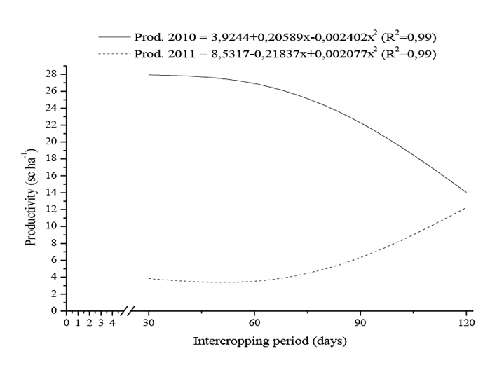
Figure 6. Productivity of the coffee plants on each intercropping period with the legumes (30, 60, 90 and 120 DASL) in the agricultural years 2009/2010 (Prod. 2010) and 2010/2011 (Prod. 2011).

