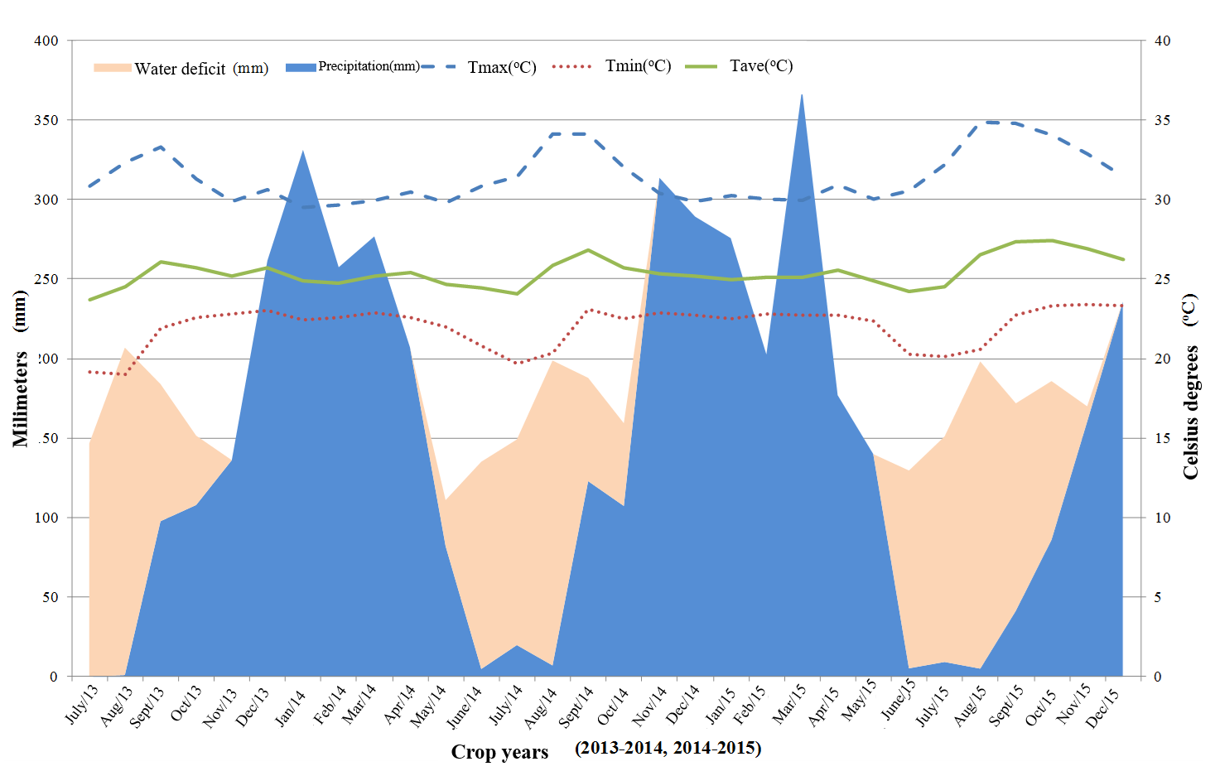

**Figure 1.** Climatic variables evaluated in the period from July 2013 to December 2015 in the city of Ouro Presto do Oeste – RO, represented by water deficit (mm) precipitation (mm) and maximum temperature, minimum and average (oC).

**Table 1.** Genetic parameters for characteristics number of days (ND) and thermal sum () of fruit ripening, estimated from the assessment of 130 Coffee canephora clones, in the crop years of 2013-2014 and 2014-2015 in the city Ouro Preto of Oeste, Rondônia.

|  |  |  |  |  |
| --- | --- | --- | --- | --- |
| **Genetic parameters** | **ND  2013-2014** | **ND  2014-2015** | **2013-2014** | () **2014-2015** |
| Genotypic variance () | 274,8 | 208,45 | 46951,24 | 35293,21 |
| Residual variance () | 82,12 | 114,69 | 13691,7 | 16231,26 |
| Phenotypic variance () | 356,93 | 323,14 | 60642,94 | 51524,46 |
| Estimate of ANOVA test (*F*) | 23,26** | 13,13** | 24,02** | 15,77** |
| Broad sense heritability ()**1** | 0,77±0,06 | 0,65±0,08 | 0,77±0,07 | 0,69±0,09 |
| Heritability of clones average () | 0,95 | 0,92 | 0,95 | 0,93 |
| Clonal selection Accuracy () | 0,97 | 0,96 | 0,98 | 0,96 |
| Coefficient of genotypic variation () | 5,71 | 5,08 | 5,64 | 4,91 |
| Coefficient of residual variation () | 3,12 | 3,77 | 3,05 | 3,33 |
| Coefficient of relative variation ()**2** | 1,83 | 1,34 | 1,85 | 1,48 |
| Variance of the error () | 13,03 | 14,51 | 2176,18 | 2512,62 |
| DP of genotypic value predicted () | 3,61 | 4,18 | 46,64 | 50,13 |
| General average () | 289,93 | 284,02 | 3840,86 | 3824,41 |

**: significant at 1% probability by F test : F test of variance analysis of the effect of genotypes,**1** Heritability in a broad sense associated with its standard deviation **2**.

**Table 2.** Genetic parameters of conjoint analysis of the number of days (ND) and the thermal sum (**) of fruit ripening of 130 clones of Coffea canephora evaluated in the crop years 2013-2014 and 2014-2015. Experimental field of Ouro Preto do Oeste (RO).

|  |  |  |  |
| --- | --- | --- | --- |
| **Genetic parameters** | **ND** |  |  |
| Genotypic variance () | 207,56 | 35332,56 |  |
| Variance of the permanent effects of environment () | 24,29 | 4421,71 |  |
| Residual variance () | 91,99 | 13893,07 |  |
| Phenotypic individual variance () | 323,84 | 53647,35 |  |
| Broad sense heritability ()1 | 0,64±0,05 | 0,66±0,05 |  |
| Repeatability ()2 | 0,72±0,06 | 0,74±0,06 |  |
| Coefficient of determination of permanent effects () | 0,07 | 0,08 |  |
| General average | 287,71 | 3842,83 |  |

**1** Heritability in broad sense associated with its standard deviation **2** Repeatability associated to its standard deviation.

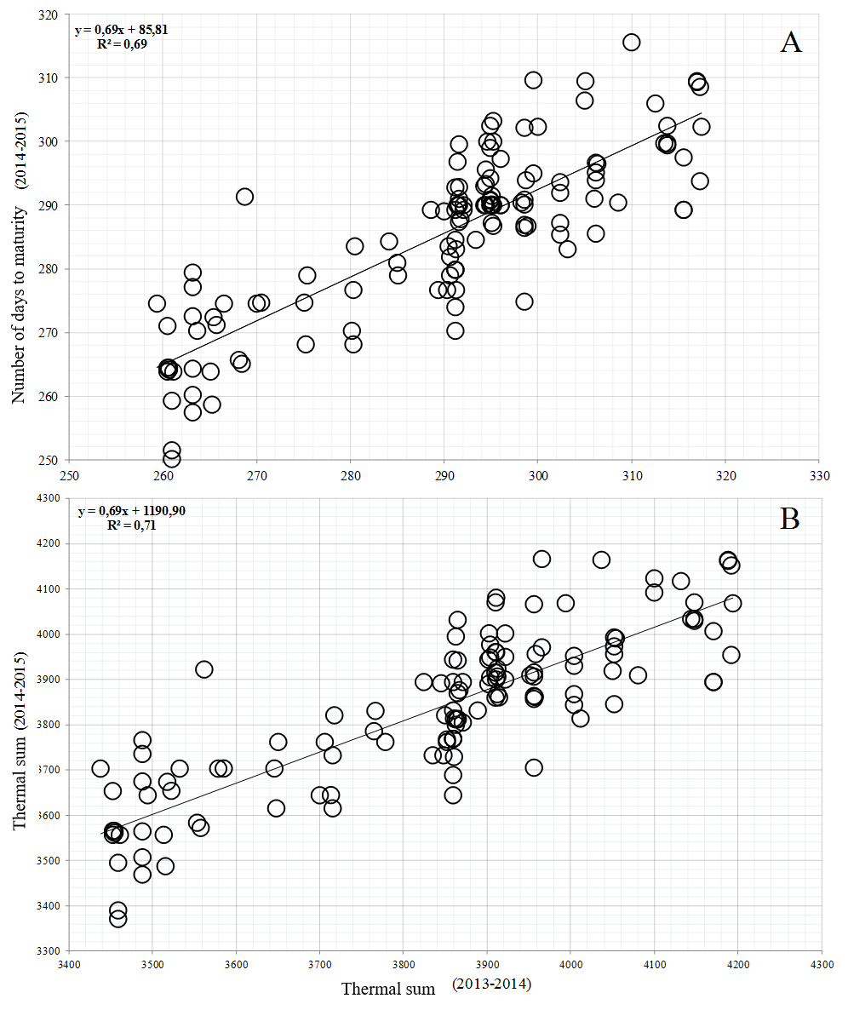

**Figure 2.** Distribution of genotypic values ​​of the number of days (A) and thermal sum (B) for fruit ripening 130 clones of Coffea canephora evaluated during crop years 2013-2014 and 2014-2015 in the city of Ouro Preto do Oeste - Rondônia.



**Figure 3.** Dendrogram obtained by: UPGMA the method, classifying the 130 clones of *C*. *canephora* in agricultural years 2013/2014 and 2014/2015 in relation to the estimates of the thermal sum for fruit ripening. The arrows indicate the changes in the groupings that occur from one year to the next.