**TABELA 1** - Valores-p obtidos para os testes de Shapiro-Wilk, Durbin-Watson e Breusch-Pagan, considerando os regimes de irrigação testemunha, 20 e 60 kPa, 20 e 60 kPaR, nas densidades de plantio 5000 (A) e 10000 plantas ha-1 (B)

A.

|  |  |  |  |  |  |  |  |  |  |  |
| --- | --- | --- | --- | --- | --- | --- | --- | --- | --- | --- |
| Regimes  Testes/  Modelos | Testemunha | | 20 kPa | | 20 kPaR | | 60 kPa | | 60 kPaR | |
| B | L | B | L | B | L | B | L | B | L |
| DW | 0,24 | 0,51 | 0,89 | 0,88 | 0,59 | 0,86 | 0,43 | 0,61 | 0,66 | 0,97 |
| BP | 0,67 | 0,82 | 0,79 | 0,66 | 0,91 | 0,64 | 0,23 | 0,19 | 0,37 | 0,32 |
| SW | 0,16 | 0,14 | 0,22 | 0,26 | 0,44 | 0,62 | 0,70 | 0,29 | 0,64 | 0,73 |

B.

|  |  |  |  |  |  |  |  |  |  |  |
| --- | --- | --- | --- | --- | --- | --- | --- | --- | --- | --- |
| Regimes  Testes/  Modelos | Testemunha | | 20 kPa | | 20 kPaR | | 60 kPa | | 60 kPaR | |
| B | L | B | L | B | L | B | L | B | L |
| DW | 0,47 | 0,81 | 0,23 | 0,43 | 0,32 | 0,61 | 0,96 | 0,86 | 0,67 | 0,84 |
| BP | 0,13 | 0,14 | 0,12 | 0,20 | 0,10 | 0,11 | 0,12 | 0,10 | 0,18 | 0,19 |
| SW | 0,67 | 0,22 | 0,86 | 0,85 | 0,50 | 0,41 | 0,52 | 0,18 | 0,16 | 0,13 |

DW – Durbin-Watson; BP – Breusch-Pagan; SW – Shapiro-Wilk

**TABLE 1 -** p-values obtained for the Shapiro-Wilk test, Durbin-Watson and Breusch- Pagan, considering the irrigation systems non-irrigated, 20 and 60 kPa, 20 and 60 kPaR, the planting densities 5000 (A) and 10000 plants ha-1 (B)

A.

|  |  |  |  |  |  |  |  |  |  |  |
| --- | --- | --- | --- | --- | --- | --- | --- | --- | --- | --- |
| Systems  Tests/  Models | Non irrigated | | 20 kPa | | 20 kPaR | | 60 kPa | | 60 kPaR | |
| B | L | B | L | B | L | B | L | B | L |
| DW | 0,24 | 0,51 | 0,89 | 0,88 | 0,59 | 0,86 | 0,43 | 0,61 | 0,66 | 0,97 |
| BP | 0,67 | 0,82 | 0,79 | 0,66 | 0,91 | 0,64 | 0,23 | 0,19 | 0,37 | 0,32 |
| SW | 0,16 | 0,14 | 0,22 | 0,26 | 0,44 | 0,62 | 0,70 | 0,29 | 0,64 | 0,73 |

B.

|  |  |  |  |  |  |  |  |  |  |  |
| --- | --- | --- | --- | --- | --- | --- | --- | --- | --- | --- |
| Systems  Tests/  Models | Non irrigated | | 20 kPa | | 20 kPaR | | 60 kPa | | 60 kPaR | |
| B | L | B | L | B | L | B | L | B | L |
| DW | 0,47 | 0,81 | 0,23 | 0,43 | 0,32 | 0,61 | 0,96 | 0,86 | 0,67 | 0,84 |
| BP | 0,13 | 0,14 | 0,12 | 0,20 | 0,10 | 0,11 | 0,12 | 0,10 | 0,18 | 0,19 |
| SW | 0,67 | 0,22 | 0,86 | 0,85 | 0,50 | 0,41 | 0,52 | 0,18 | 0,16 | 0,13 |

DW – Durbin-Watson; BP – Breusch-Pagan; SW – Shapiro-Wilk

**TABELA 2 -** Estimativas para o coeficiente de determinação ajustado e critério de informação de Akaike corrigido, considerando os regimes de irrigação testemunha, 20 e 60 kPa, 20 e 60 kPaR, nas densidades de plantio 5000 (A) e 10000 plantas ha-1 (B)

A.

|  |  |  |  |  |  |  |  |  |  |  |
| --- | --- | --- | --- | --- | --- | --- | --- | --- | --- | --- |
| Critérios | Testemunha | | 20 kPa | | 20 kPaR | | 60 kPa | | 60 kPaR | |
| B | L | B | L | B | L | B | L | B | L |
| R² (%) | 95,28 | 95,72 | 94,04 | 94,20 | 92,53 | 93,01 | 91,72 | 92,03 | 91,50 | 91,97 |
| AICc | -22,01 | -23,11 | -17,74 | -18,06 | -15,62 | -16,33 | -14,48 | -14,89 | -14,02 | -14,62 |

B.

|  |  |  |  |  |  |  |  |  |  |  |
| --- | --- | --- | --- | --- | --- | --- | --- | --- | --- | --- |
| Critérios | Testemunha | | 20 kPa | | 20 kPaR | | 60 kPa | | 60 kPaR | |
| B | L | B | L | B | L | B | L | B | L |
| R² (%) | 96,96 | 97,07 | 95,93 | 96,26 | 95,23 | 95,52 | 94,02 | 93,99 | 95,10 | 95,13 |
| AICc | -26,51 | -26,96 | -21,55 | -22,49 | -19,93 | -20,63 | -17,59 | -17,55 | -19,52 | -19,61 |

B – Brody; L – Logistic

**TABLE 2 -** Estimates for the adjusted coefficient of determination and Akaike information criterion corrected, considering the irrigation systems non-irrigated, 20 and 60 kPa, 20 and 60 kPaR, the planting densities 5000 (A) and 10000 plants ha-1 (B)

A.

|  |  |  |  |  |  |  |  |  |  |  |
| --- | --- | --- | --- | --- | --- | --- | --- | --- | --- | --- |
| Criteria | Non irrigated | | 20 kPa | | 20 kPaR | | 60 kPa | | 60 kPaR | |
| B | L | B | L | B | L | B | L | B | L |
| R² (%) | 95,28 | 95,72 | 94,04 | 94,20 | 92,53 | 93,01 | 91,72 | 92,03 | 91,50 | 91,97 |
| AICc | -22,01 | -23,11 | -17,74 | -18,06 | -15,62 | -16,33 | -14,48 | -14,89 | -14,02 | -14,62 |

B.

|  |  |  |  |  |  |  |  |  |  |  |
| --- | --- | --- | --- | --- | --- | --- | --- | --- | --- | --- |
| Criteria | Non irrigated | | 20 kPa | | 20 kPaR | | 60 kPa | | 60 kPaR | |
| B | L | B | L | B | L | B | L | B | L |
| R² (%) | 96,96 | 97,07 | 95,93 | 96,26 | 95,23 | 95,52 | 94,02 | 93,99 | 95,10 | 95,13 |
| AICc | -26,51 | -26,96 | -21,55 | -22,49 | -19,93 | -20,63 | -17,59 | -17,55 | -19,52 | -19,61 |

B – Brody; L – Logistic

**TABELA 3 -** Estimativas para os parâmetros do modelo Logístico nos regimes de irrigação testemunha, 20 e 60 kPa, 20 e 60 kPaR e nas densidades de plantio 5000 (A) e 10000 plantas ha-1 (B)

A.

|  |  |  |  |  |  |
| --- | --- | --- | --- | --- | --- |
| Regimes/  Parâmetros | Testemunha | 20 kPa | 20 kPaR | 60 kPa | 60 kPaR |
| α | 1,99 | 2,19 | 2,21 | 2,22 | 2,12 |
| β | 41,36 | 28,69 | 17,88 | 7,25 | 25,45 |
| k | 0,0045 | 0,0049 | 0,0050 | 0,0046 | 0,0046 |

B.

|  |  |  |  |  |  |
| --- | --- | --- | --- | --- | --- |
| Regimes/  Parâmetros | Testemunha | 20 kPa | 20 kPaR | 60 kPa | 60 kPaR |
| α | 2,14 | 2,25 | 2,22 | 2,26 | 2,22 |
| β | 22,74 | 30,21 | 27,24 | 6,58 | 25,75 |
| k | 0,0038 | 0,0044 | 0,0042 | 0,0040 | 0,0039 |

**TABLE 3** - Estimates for the parameters of Logistic model in irrigation systems non irrigated, 20 and 60 kPa, 20 and 60 kPaR and planting densities in 5000 (A) and 10000 plants ha-1 (B)

A.

|  |  |  |  |  |  |
| --- | --- | --- | --- | --- | --- |
| Systems/  Parameters | Non irrigated | 20 kPa | 20 kPaR | 60 kPa | 60 kPaR |
| α | 1,99 | 2,19 | 2,21 | 2,22 | 2,12 |
| β | 41,36 | 28,69 | 17,88 | 7,25 | 25,45 |
| k | 0,0045 | 0,0049 | 0,0050 | 0,0046 | 0,0046 |

B.

|  |  |  |  |  |  |
| --- | --- | --- | --- | --- | --- |
| Systems/  Parameters | Non irrigated | 20 kPa | 20 kPaR | 60 kPa | 60 kPaR |
| α | 2,14 | 2,25 | 2,22 | 2,26 | 2,22 |
| β | 22,74 | 30,21 | 27,24 | 6,58 | 25,75 |
| k | 0,0038 | 0,0044 | 0,0042 | 0,0040 | 0,0039 |

A. B.

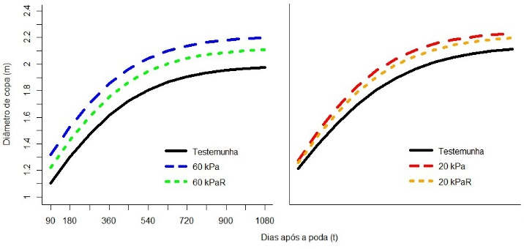

**FIGURA 1** - Ajustes do modelo Logístico considerando a densidade de plantio 5000 plantas ha-1 e os regimes de irrigação testemunha, 60 kPa e 60 kPaR (A) e a densidade 10000 plantas ha-1 e os regimes de irrigação testemunha, 20 kPa e 20 kPaR (B).

A. B.

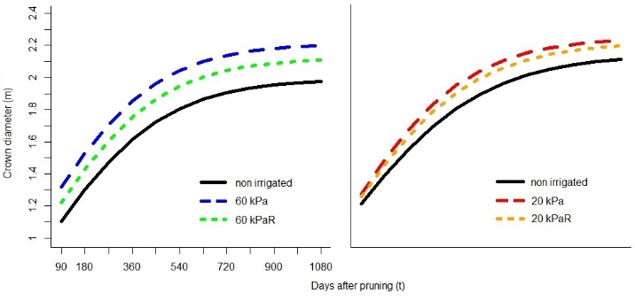

**FIGURE 1** - Model adjustments Logistic considering planting density 5000 plants ha-1 and the irrigation systems non irrigated, 60 kPa and 60 kPaR (A) and the density of 10000 plants ha-1 and the irrigation systems non irrigated, 20 kPa and 20 kPaR (B).