**Table 1**. Description of treatments: number of stems per plant and the number of stems per hectare

|  |  |  |  |
| --- | --- | --- | --- |
| **Treatment** | **Description** | **Number of stems per plant** | **Number of stems per hectare** |
| T1 | Traditional pruning without removal of reproductive branches | 2 | 8.000 |
| T2 | “CPPAC” with removal of 70% of reproductive branches that produced in the season | 2 | 8.000 |
| T3 | “CPPAC” with removal of 50% of reproductive branches that produced in the season | 2 | 8.000 |
| T4 | Traditional pruning without removal of reproductive branches | 3 | 12.000 |
| T5 | “CPPAC” with removal of 70% of reproductive branches that produced in the season | 3 | 12.000 |
| T6 | “CPPAC” with removal of 50% of reproductive branches that produced in the season | 3 | 12.000 |

CPPAC = Cyclic Pruning Program for Arabica Coffee.

**Tabela 1.** Descrição dos tratamentos: número de haste por planta e número de hastes por hectare

|  |  |  |  |
| --- | --- | --- | --- |
| **Trat** | **Descrição** | **Nºhastes planta-1** | **Nºhastes ha-1** |
| T1 | Poda tradicional, sem retirada de ramos plagiotrópicos | 2 | 8.000 |
| T2 | PPCA com retirada dos ramos plagiotrópicos que produziram 70% | 2 | 8.000 |
| T3 | PPCA com retirada dos ramos plagiotrópicos que produziram 50% | 2 | 8.000 |
| T4 | Poda tradicional, sem retirada de ramos plagiotrópicos | 3 | 12.000 |
| T5 | PPCA com retirada dos ramos plagiotrópicos que produziram 70% | 3 | 12.000 |
| T6 | PPCA com retirada dos ramos plagiotrópicos que produziram 50% | 3 | 12.000 |

(PPCA) Poda Programada de Ciclo do Café Arábica.

**Table 2**. Means of crop yield (bags ha-1) along five consecutive harvests of Catuaí Vermelho IAC 81 conducted with six pruning managements, Alto Mutum Claro, Baixo Guandú, Espírito Santo, Brazil.

|  |  |  |  |  |  |  |
| --- | --- | --- | --- | --- | --- | --- |
| **Treat-ment** | **Management** | **2010** | **2011** | **2012** | **2013** | **2014** |
| T1 | 2 stems per plant, Traditional pruning, without removal of reproductive branches | 43.67 AB a | 46.22 A b | 33.36 C ab | 22.55 D c | 33.41 BC abc |
| T2 | 2 stems per plant, “CPPAC” with removal of reproductive branches which produced 70% | 45.61 A a | 42.11 A b | 38.61 AB a | 31.64 B bc | 41.57 AB a |
| T3 | 2 stems per plant, “CPPAC” with removal of reproductive branches which produced 50% | 49.88 A a | 39.83 AB b | 34.31 B ab | 23.74 C c | 39.64 AB ab |
| T4 | 3 stems per plant, Traditional pruning without removal of reproductive branches | 39.65 B a | 75.30 A a | 22.51 C c | 38.52 B ab | 36.70 B abc |
| T5 | 3 stems per plant, “CPPAC” with removal of reproductive branches which produced 70% | 46.99 B a | 74.58 A a | 30.94 C abc | 48.75 B a | 29.74 C bc |
| T6 | 3 stems per plant, “CPPAC” with removal of reproductive branches which produced 50% | 45.21 B a | 65.87 A a | 26.87 C bc | 48.19 B a | 26.98 C c |
| **Mean** |  | 45.17 B | 57.32 A | 31.10 D | 35.57 C | 34.67 CD |
| Cyclic Pruning Program for Arabica Coffee | | | | | | |

Means followed by the same lower case letter in the column or capital on the line do not differ statistically by Tukey test at 5% probability.

**Tabela 2**.Médias de produtividades (sc ha-1) de cinco safras consecutivas da cultivar Catuaí Vermelho IAC 81 conduzida com seis manejos de poda, tanto a tradicional como a Poda Programada de Ciclo do Café Arábica (PPCA), Alto Mutum Claro, Baixo Guandú, ES

|  |  |  |  |  |  |  |
| --- | --- | --- | --- | --- | --- | --- |
| **Trat** | **Manejo** | **2010** | **2011** | **2012** | **2013** | **2014** |
| T1 | 2 hastes/pl., poda tradicional, sem retirada de ramos plagiotrópicos | 43,67 AB a | 46,22 A b | 33,36 C ab | 22,55 D c | 33,41 BC abc |
| T2 | 2 hastes/pl., PPCA com retirada dos ramos plagiotrópicos que produziu 70% | 45,61 A a | 42,11 A b | 38,61 AB a | 31,64 B bc | 41,57 AB a |
| T3 | 2 hastes/pl., PPCA com retirada dos ramos plagiotrópicos que produziu 50% | 49,88 A a | 39,83 AB b | 34,31 B ab | 23,74 C c | 39,64 AB ab |
| T4 | 3 hastes/pl., poda tradicional, sem retirada de ramos plagiotrópicos | 39,65 B a | 75,30 A a | 22,51 C c | 38,52 B ab | 36,70 B abc |
| T5 | 3 hastes/pl., PPCA com retirada dos ramos plagiotrópicos que produziu 70% | 46,99 B a | 74,58 A a | 30,94 C abc | 48,75 B a | 29,74 C bc |
| T6 | 3 hastes/pl., PPCA com retirada dos ramos plagiotrópicos que produziu 50% | 45,21 B a | 65,87 A a | 26,87 C bc | 48,19 B a | 26,98 C c |
| **Média** |  | 45,17 B | 57,32 A | 31,10 D | 35,57 C | 34,67 CD |

Médias seguidas pela mesma letra minúscula na coluna ou maiúscula na linha não diferem estatisticamente entre si pelo teste de Tukey, a 5% de probabilidade.

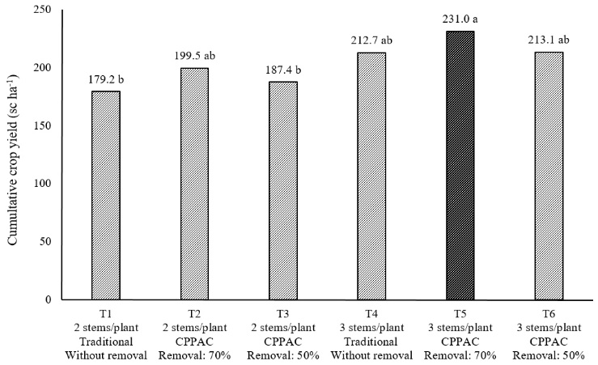

**Figure 1**. Cumulative crop yield of six treatments in five years, of Catuaí Vermelho IAC 81 conducted with six pruning managements, Alto Mutum Claro, Baixo Guandú, Espírito Santo, Brazil.

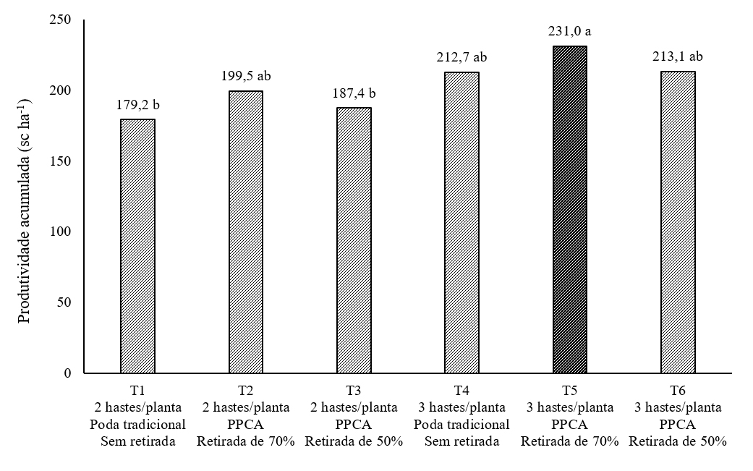

**Figura 1**.Produção acumulada de seis tratamentos em cinco anos, em sc ha-1, da variedade Catuai Vermelho IAC 81, conduzida sob novo sistema de condução de plantas em café arábica (PPCA), Alto Mutum Claro, Baixo Guandú, ES.

**Table 3**. Proportion of ripe, green, dry and void fruits, and harvest speed (bags / d / h) of Catuaí Vermelho IAC 81 conducted with traditional pruning and under new Cyclic Pruning Program for Arabica Coffee (CPPAC), in Alto Mutum Claro, Baixo Guandú, Espírito Santo, Brazil.

|  |  |  |  |  |  |
| --- | --- | --- | --- | --- | --- |
| Treatments* | Proportion of fruits (%) | | | | Harvest speed |
| Ripe | Green | Dry | Void | bags (80 L) / d / h |
| T1 | 63.0 | 26.4 | 5.7 | 4.9 | 5 to 7 |
| T2 | 71.7 | 25.7 | 1.6 | 1.0 | 10 to 14 |
| T5 | 71.4 | 24.8 | 1.7 | 2.1 | 10 to 12 |

* T1 = 2 stems per plant, Traditional pruning, without removal of reproductive branches; T2 = 2 stems per plant, “CPPAC” with removal of reproductive branches which produced 70%; T5 = 3 stems per plant, “CPPAC” with removal of reproductive branches which produced 70%.

**Tabela 3.** Características de frutos colhidos: cerejas, verdes, secos e chochos em percentagem e rapidez de colheita (sacos/d/h) da cultivar Catuai Vermelho IAC 81 conduzida com a poda tradicional e sob novo sistema de Poda Programada de Ciclo do café arábica (PPCA) em Alto Mutum Claro, Baixo Guandú, ES

|  |  |  |  |  |  |
| --- | --- | --- | --- | --- | --- |
| Tratamentos* | Frutos (%) | | |  | Sacos/d/h |
| Cerejas | Verdes | Secos | Chochos | Sacos de 80 Litros |
| T1 | 63,0 | 26,4 | 5,7 | 4,9 | 5 a 7 |
| T2 | 71,7 | 25,7 | 1,6 | 1,0 | 10 a 14 |
| T5 | 71,4 | 24,8 | 1,7 | 2,1 | 10 a 12 |

* T1 = 2 hastes ortotrópicas/planta, poda tradicional, sem retirada de plagiotrópicos; T2= 2 hastes ortotrópicas/planta, com a PPCA com retirada de plagiotrópicos que produziu 70%; T5= 3 hastes ortotrópicas/planta, com a PPCA com retirada de plagiotrópicos que produziu 70%.